History at Home
with the
Milwaukee County Historical Society
Mary Jo Knapp
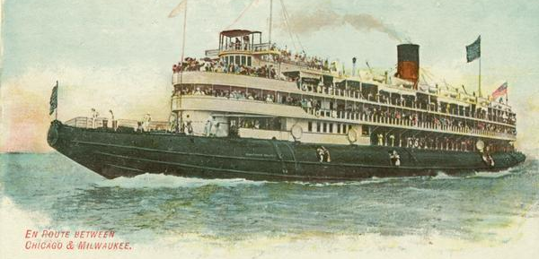
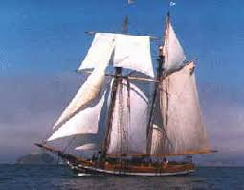
Family Activities Jobs That Built Wisconsin – Shipping
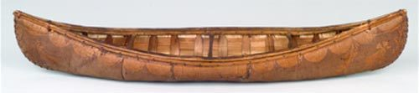
Schooners (sails) Canoes Steamers (waterwheels)
This Photo by Unknown Author is licensed under CC BY

Water in Milwaukee and Wisconsin is one of our biggest assets and natural resources. Native Americans chose to settle in our area because of the plentiful and clean water to use for food, drink, building supplies, and transportation. Some of the most prominent water sources are: Lake Michigan, Lake Superior, Mississippi River, Milwaukee River, Kinnickinnic River, Menomonee River and the Wisconsin River. Even far away in New York, the Erie Canal, played a big part on Milwaukee’s business growth.
Native Americans would have drunk the water, hunted and fished for food, gathered grain like wild rice, harvested tall grasses, and used the water to move from one place to another.
Activity: What kind of animals would live in Wisconsin’s waters? Research and find at least 5 that are native to Wisconsin.
The first immigrants used the river as well for transportation and for food.
After the Milwaukeeans built their businesses, they would also transport their products to sell elsewhere. Milwaukee became the shipping hub of Wisconsin and other states’ businesses would drop off materials here to sell and we would also have the farm’s products to sell to others. Things Wisconsinites would sell: wheat, flour, paper, lumber, furs, textiles, meat, leather products, beer, and motors. Soon, Milwaukee had a “freeway of schooners up and down our lakefront and through our rivers. Next time you drive down towards the lake, look for warehouses and grain elevators. These buildings would have stored materials from the shipping docks to either sell, process, and move. Our grain elevators alone could hold 2,000,000 bushels of grain.
Activity: Do you have any toy boats at home? Can you create one? What sinks and floats? How can ships that carried several tons of products (wood, bricks, wheat, barley, animal hides) be able to not sink?
Play Battleship with a family member.
Make a salt dough landscape at home. Show Milwaukee’s bluffs, rivers and Lake Michigan. https://www.allrecipes.com/recipe/240641/salt-dough/

